**CMS Submission Report Checks Tool**

***\*The tool will be sent out to the team within 2 weeks of the start of submissions***

1. Open the tool.
2. On both the IP PPR and OP PPR tabs, click on the ‘Import’ button to import the Provider Participation Reports that you have downloaded from HQR.A screenshot of a computer

   Description automatically generated A picture containing arrow

   Description automatically generated
3. In the file explorer window, navigate to where you saved the PPRs you downloaded from HQR. Select the appropriate PPR (IP or OP) either by double clicking on the file or selecting the file and clicking ‘Open’. Graphical user interface, text, application

   Description automatically generated
4. You’ll get a pop up message stating the import was successful. Click ‘OK’. Graphical user interface, application

   Description automatically generated
5. Search for any issues and investigate. Issues will be highlighted in red. *\*See notes section of this article for explanations on each rule.*
6. If errors are OK, you can select ‘Yes’ in the Validated Errors column to override the red warnings. This will turn the errors green. You can utilize the Notes column to document why this error is OK. If the errors need to be corrected, take necessary steps with the client to get data corrected and then repeat steps 2 to 5.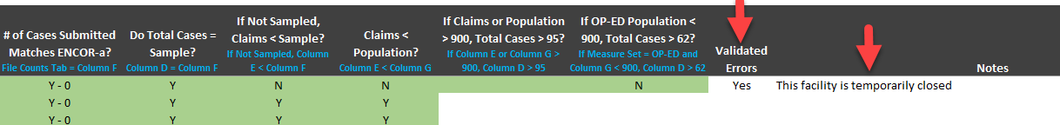
7. Use the File Counts tab to copy and paste your file counts from the submission tracker. This will allow you to be able to check your submitted file counts vs. the file counts you got from ENCOR-a.

**Notes:**

* On both the IP PPR and OP PPR tabs, you can clear the PPR data from the tool should you choose by clicking on the ‘Clear’ button. **You do not have to clear the data from the tool each time you need to import a new PPR. Importing a new PPR will overwrite the existing data.**

* What do the rules check for in columns J-N on the IP PPR tab? Any rule that is broken will be flagged in red.
  + Column J checks that the file counts you entered on your submission tracker from ENCOR-a match what was submitted to CMS.
  + Column K checks to make sure the Total Cases equal the Sample Size.
  + Column L checks to make sure that if the measure set is not sampled, the Total Claims are not more than the Sample Size.
  + Column M checks to make sure the Population Size is greater than or equal to the Total Claims.
  + Column N checks to make sure the Population Size is greater than or equal to the Total Cases.
* What do the rules check for in columns L-Q on the OP PPR tab? Any rule that is broken will be flagged in red.
  + Column L checks that the file counts you entered on your submission tracker from ENCOR-a match what was submitted to CMS.
  + Column M checks to make sure the Total Cases equal the Sample Size.
  + Column N checks to make sure that if the measure set is not sampled, the Total Claims are not more than the Sample Size.
  + Column O checks to make sure the Population Size is greater than or equal to the Total Claims.
  + Columns P & Q check to make sure the quarterly sample size requirement for OP-ED has been met.
    - Column P – if there are greater than 900 cases per quarter, are there at least 96 cases in the sample?
    - Column Q – if there are less than 900 cases per quarter, are there at least 63 cases in the sample?
* CCNs with a leading zero will only display 5 digits, not 6. This is how they are exported from HQR, so the tool matches that. Text

  Description automatically generated
* You can filter on a specific Advisor on all three tabs by selecting a name in the drop down list. To remove the filter, click on the ‘Cancel Filter’ icon.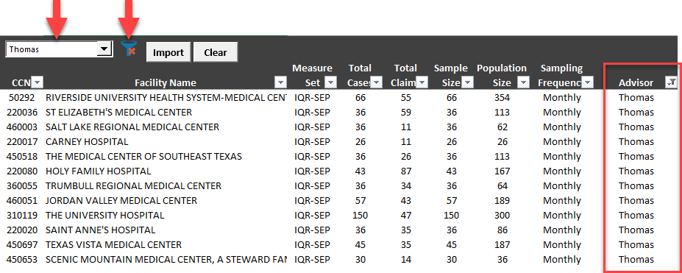
* Editing most cells is not allowed to protect the integrity of the tool. Trying to do so will cause a warning message to appear. You can only edit the Validated Errors column and the Notes column.Graphical user interface, application

  Description automatically generated

**IMPORTANT:**

* To not lose your notes in the tool (i.e. facilities shifting to different rows causing your notes to not be in the correct row), each time you import a new PPR, **make sure you select the same facilities in HQR before downloading the PPR as you did the very first time you downloaded it.**
  + For example, if you only selected your facilities when you downloaded and imported the PPR, each subsequent time you download and import a new PPR, you should select only your facilities.
  + **The suggestion would be to download the PPRs from HQR for ALL facilities every single time and import them into the tool.**